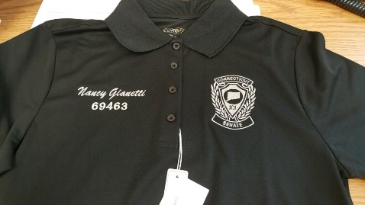
CT Jaycee Senate 2020 Shirt Order Form
COLOR—CAMPUS GOLD
Pricing includes embroidery for CT JCI Senate logo
To add Name/Senate # add $10.00 per shirt

Name: ________________________________________________________________________
Senate #_________________________________ Phone#:______________________________
LADIES:
STYLE: Sizes  XS-XL | ORDER # | PRICE | EXTRA SIZE FEE | SIZE | QUANTITY | TOTAL
Short Sleeve-Button Down | 78194 | $36.00
Long Sleeve-Button Down | 78193 | $38.00

MENS:
STYLE: Sizes S-XL | ORDER # | PRICE | EXTRA SIZE FEE | SIZE | QUANTITY | TOTAL
Short Sleeve-Button Down | 88194 | $36.00
Long Sleeve-Button Down | 88193 | $38.00

EXTRA SIZE FEE: 2XL- add $2.50 per shirt; 3XL-add $3.50 per shirt; 4XL-add $4.50 per shirt; 5XL-add $5.50 per shirt
**If you get your name on the shirt(s), name will be in script**
Add Name & Senate # | Yes or No | $10 per shirt

To see color—go to their website:
https://www.4logowearables.com/cgi-bin/hw/hwb/chw-display-PLstyle.w?sr=88194&currentColor=&hwCN=153150154&hwCNCD=153150154&hwST=1
Please make checks out to CT JCI Senate and mail to:
Cathy Dempsey, Senator #67625, 1124 Waterbury Road, Cheshire, CT 06410, Cell 203-910-4692,
Email: cadmpsy752@earthlink.net

